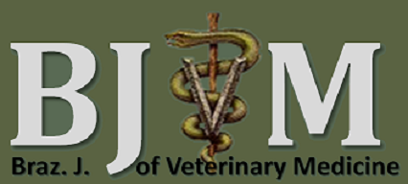
Sociedade de Medicina Veterinária do Rio de Janeiro
(SOMVERJ) - Periódico Técnico Científico
Endereço para correspondência: UFRRJ, IV, Anexo 1, DPA. BR 465 Km 7,
Seropédica, RJ – CP.: 23890-000

DISCLAIMER AND COPYRIGHT TRANSFER AGREEMENT
First author (responsible for correspondence)
_________________________________________
Article title:
_____________________________________________________________________________
- Agreement of responsibility: All people below listed as authors should sign this agreement the responsibility:
• All the authors were informed of the policies and norms of the Brazilian Journal of veterinary medicine and agree to comply with all its requirements.
• The total content and the article submitted has not been partial and will not be submitted for your publication to another journal or scientific and technical publication (printed, electronic or not) during the time that lasts the processes of peer review and editing in Brazilian Journal of veterinary medicine.
• All authors have read the final version of the article presented and are correspondents for all concepts and text information and images presented. Brazilian Journal of veterinary medicine is not responsible for the veracity and authenticity of this information.
• Do not have conflict of interest, and if the article is accepted for publication your approve the transfer of the Brazilian Journal of Veterinary Medicine.

Signature of the author (s):

- Transfer of Copyright: I declare that, if the manuscript is accepted, I agree that your copyright will be transferred to the exclusive ownership of Brazilian Journal of veterinary medicine. All reproduction for personal use is allowed, as well as the partial reproduction is also permitted, but the original reference should be cited.

Signature of the author (s)

